DATA TEST PRACTICE
SUCCESSIVE IONISATION ENERGIES

Question A
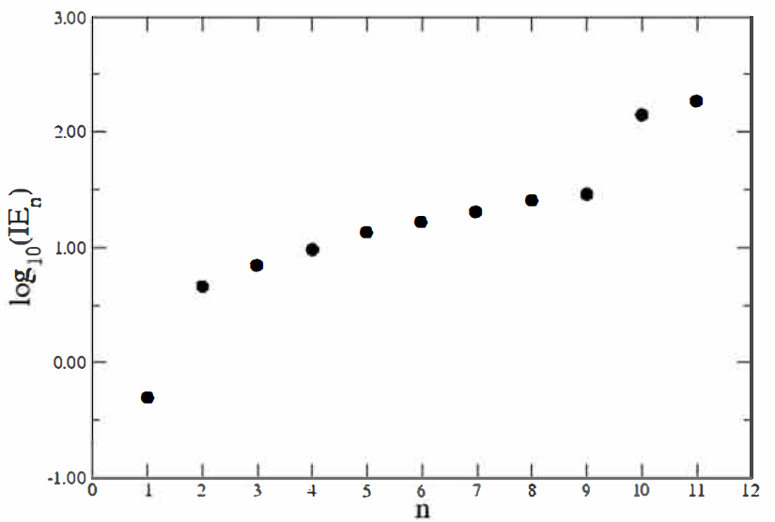
The graph below shows the successive ionization energies of an element X.

1. Using X to symbolize the element write an equation to show the fourth ionization energy of the element.
2. On the graph circle and label the two electrons which are closest to the nucleus
3. Identify a trend which this graph provides evidence for?
4. What group is the element in? Justify your answer using data from the graph.
5. Which element is X likely to be? Justify your answer using data from the graph.
6. On the graph draw a dot where the 12th ionization energy would be expected to be.

Question B
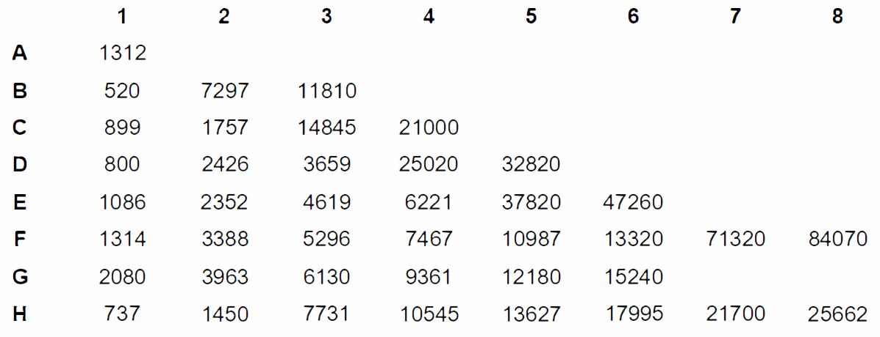
Successive Ionization energies can also be shown using tables as shown below. The below has the successive ionization energies of some unknown elements.

8. Determine the groups of the following elements and give a reason for your answer.
a) C
b) D
c) F
d) G
9. Two of the 8 elements belong to the same group
a. Identify the 2 elements
b. Compare and contrast their ionization values
c. Give reasons for your answer to the above question (think about it – what reason could explain the differences?)

